Specifications

- Collision detector used on the back of a car bumper. It gives out an audible warning in terms of “beeps.” The frequency of the “beeps” increases as the transducers get closer to the solid object.

- The collision detector must be application specific. Used with small vehicles i.e. cars when reversing from a distance of 1.5m to 0.1m. Used when reversing towards a solid dense surface, wall garage door etc.

Problems

Even with the dishes in place there is no distinguishable change in the input signal strength when moving the transducers from 2.5 – 1.5m. If this was true then it could be used specifically for vans parking and unloading( allot of space is needed when opening the back doors of a van). The specification is now changed, the collision detector shall be used on cars, which need a smaller
- Do the transducers have to be angled in order to receive best signal?

Using trigonometry (for a distance of 1.5m from the wall) the best signal can be received by the transducers when angled at:

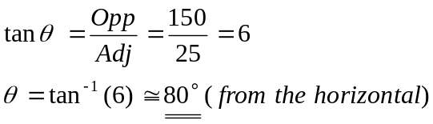

Using trigonometry (for a distance of 0.1m from the wall) the best signal can be received by the transducers when angled at:

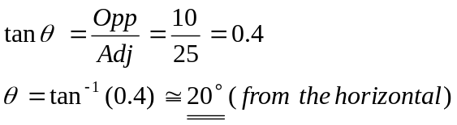

For the transducers to work effectively there has to be a trade off in the appropriate angle used. By choosing an angle in-between 20 and 80 degrees (i.e. 50 degrees to the horizontal) the effectiveness of the transducers can now be evaluated by practical testing.

Not only does the angle of reflection have to be worked out to get best results but do we use “dishes” on each of the transducers to focus the signal or not?
What combination do we use:
- Transmitter with dish, receiver without.
- Receiver with dish, transmitter without.
- Transmitter and receiver with dish.
- Transmitter and receiver without dish.

When these tests are satisfied then the system can then be “bread boarded.”

The best oscillator circuit to use, well the oscillator circuit which we have covered in lectures is the Wien bridge oscillator

